Grade 7 Accelerated · Unit 3 · Lesson 1  Product Laws of Exponents  Question Bank 3.01 ANSWER KEY | Name  Date  Period

Show your work. Circle your final answer.
For questions 1 and 2, write the product as a repeated multiplication expression, then as a single power.
1. 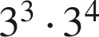
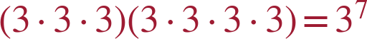
Seven factors of 3. Same base, add the exponents.

2. 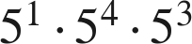
The law extends to three powers: 1 + 4 + 3 = 8.

3. Evaluate each power, then multiply. 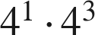
4 · 64 = 256
Also 4⁴ = 256, which is the check.

4. Apply the product of powers law, then evaluate the power. 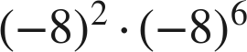

Eight negative factors: positive. A calculator confirms 8⁸.

5. Jose says he can evaluate 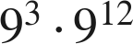 using the product of powers law. Is he correct? Explain, and write the single power.
Yes — the bases are the same, so .
The law needs matching bases and nothing else. (He would not need to evaluate 9¹⁵ to be right.)

For questions 6 through 8, use the power of a product law.
6. Write 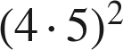 as a repeated multiplication expression, group the repeated factors, then write it in the form 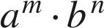.
Value 400 either way.

7. Evaluate inside the parentheses first, then apply the exponent. 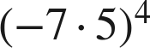

Even power of a negative: positive.

8. Apply the power of a product law, then evaluate. 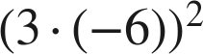

Or (−18)² = 324.

For questions 9 through 11, use the power of a power law or the identity law.
9. Write 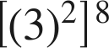 as a single power.

Multiply the exponents: 2 · 8.

10. Rewrite 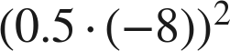 using a law of exponents, name the law, then evaluate.
— power of a product
Or (−4)² = 16.

11. Write each expression using the identity law, then give its value.
a. 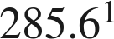
285.6
b. 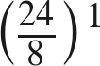
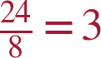

Working backwards.
12. Find the value of that makes each statement true.
a. 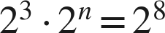
n = 5
3 + n = 8.
b. 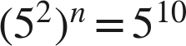
n = 5
2n = 10.
c. 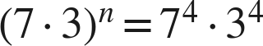
n = 4
Power of a product read backwards.

13. Which expression is equivalent to 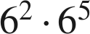 ?
● A. 
○ B. 
○ C. 
○ D. 
A
Same base, add the exponents.

14. Select ALL of the expressions that are equivalent to 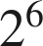.
☒ A. 
☒ B. 
☒ C. 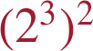
☐ D. 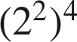
☒ E. 
☐ F. 
A, B, C and E
B: 2⁶. C: 2⁶. E: 2⁶. A: 4³ = 64 = 2⁶ — same value, different base, still equivalent. D is 2⁸; F is 2⁵.

